Chapter 3

Ionic compounds are formed from the _____________________ of ______________________. An ionic bond forms between a _______________ and a ________-________________ element, except for ionic compounds containing ______________________________.

Ionic compounds formed from _______________ ______ and ______ metals are usually _______________ or _______________________, however those formed from _______________________ metals have a variety of colours.

Ionic bonding can be described as the _________________________ attraction between the ___________________ ions (_________________) and the _______________________ ions (____________________). These ions form a __________________ ___________________.

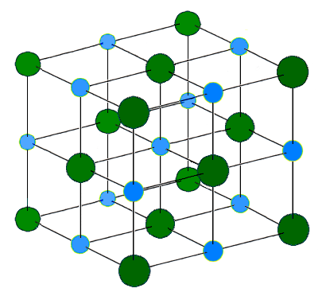
e.g.

This description of the bonding can be used to explain the different properties of ionic compounds.

Hard
This is due to the strong electrostatic attraction between the ions in the ________ ______________ making it difficult to break the bonds.

High melting and boiling point
This is due to the strong electrostatic attraction between the cations and anions, therefore a _______________ amount of heat is required to _________________ the bonding. The attractive forces between the ions in a molten ionic sample are still quite strong, therefore boiling points are ___________ ______________. Many ionic compounds will ______________________ before they reach their boiling temperatures.

Brittle
Due to the ____________________ arrangement of the ions in the _________________, an external force disturbs this structure and causes cations to line up with _______________ and anions to line up with _______________. This will cause______________________ and the crystal will ___________________.
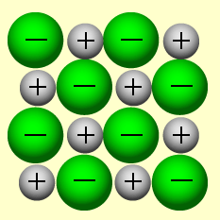
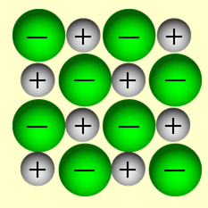

Solubility
When an ionic substance dissolves in water, it will _______________________. This means that the crystal lattice will break apart and the ions will move freely through the water.
e.g. _____________________________________________________________________
Some ionic substances do not dissolve in water due to the stability of the ionic crystal and so these remain as an ionic lattice when in solution e.g. ________________________________________

Electrical conductivity when solid
Solid ionic substances ______________ conduct electricity, because even though they contain __________________ ______________________ (the ions), these particles are not __________________, they are held in fixed positions within the lattice.

Electrical conductivity when molten
All ionic substances ____________ conduct electricity when molten i.e. _______________________. This is due to the _________________________ of the cations and anions, creating mobile charge. Both the cations and anions contribute to ______________________ the electric current.

Electrical conductivity when in aqueous solution
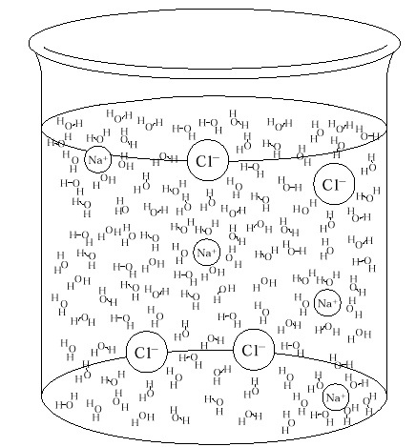
All ionic substances that are _____________________ in water will conduct electricity. This is also due to the _____________________________ of the ions. Pure water alone is not considered a good conductor of water, but when cations and anions are moving through the liquid, these ________________ ___________________ particles are able to conduct the current through the solution. Only ionic substances that are soluble will conduct electricity, since insoluble substances will obviously not produce any ions in solution.

Formulae of Ionic Compounds
Ionic compounds are composed of a cation and an anion.
These can be monatomic e.g. __________________________________________________________ or polyatomic e.g. ________________________________________________________________.
Cations are species which have overall more ________________ than ______________________, whilst anions have overall more _______________________ than ___________________. This unevenness is what gives an ion its overall _________________.
When writing the formula of an ionic compound, the charge(s) on the positive ion(s) must cancel the charge(s) on the negative ion(s). This is because a compound must always be neutral.
e.g. _________________________________________________________________________

Names of Ionic Compounds
When naming ionic compounds, the two ion names are simply placed together. Note that the metal ion does not change its name (e.g. magnesium atom becomes magnesium ion), but the non-metal ion will change from its element ending to ‘-ide’ (e.g. sulphur atom becomes sulphide ion). Therefore MgS would be named _________________________ _______________________. Polyatomic ions often have names ending in ‘-ate’ or ‘-ite’ representing the number of oxygen atoms present. Prefixes such as ‘mono-‘ ‘di-‘ and ‘tri-‘ are never used to name ionic compounds. When naming a compound where the metallic ion has more than one form (e.g. the iron ion can be 2+ or 3+) Roman numerals are used after the cation name to show which form of the ion is present. You can work out which form is present by studying the charge of the anion, which never changes.
e.g. ______________________________________________________________________________
Hydrated Ionic Compounds
Many ionic compounds are found with _______________ _____ __________________________ attached to them in their _____________ form. For example,

e.g. ___________________________________________________________________________
___________________________________________________________________________

Compounds such as these are called _______________________, due to the presence of the water crystals. These waters can affect the _______________ of the ionic compound and obviously they affect the __________________ ___________ (M) of the compound.

The waters of crystallisation can be driven from the compound with strong heating.

Ionic compounds with no waters of crystallisation are called _________________________.

Formation of Ionic Compounds
As mentioned before, ionic compounds are formed due to the transfer of electrons. All elements will react in an effort to attain a stable electron arrangement. This usually requires obtaining _______ electrons in their outer shell.
Metallic elements will generally have ______, _______ or _______ electrons in their valence shell. Therefore they will want to lose these to have a stable arrangement.
Non-metal elements will generally have _______, _______ or _______ electrons in their valence shell. Therefore they will want to gain electrons to have a stable arrangement.
(Note that the elements in Group 8 do not form ions as they already have a stable arrangement and most elements in Group 4 do not form ions because it is too hard for them to gain 4 or lose 4. The only 2 metallic elements in Group 4 are ________ and ________ and these can form ions with a charge of either ________ or ________.)

In the formation of an ionic bond, the metallic element will _______________ its valence electrons to the non-metal element, thereby creating two species which both have a _________________ _______________________ ______________________________.

e.g. NaCl

Electron Dot Diagrams
Electron dot diagrams only show the __________________ ____________________, since these are the only ones that move / change during a chemical reaction.

e.g. NaCl

e.g. AlCl₃

e.g. Na₂O

Uses of Ionic Compounds
Name | Use
Ammonium nitrate
Calcium carbonate
Calcium phosphate
Calcium sulfate
Potassium nitrate
Sodium carbonate
Sodium chloride
Sodium hydrogencarbonate
Sodium hydroxide
Sodium hypochlorite
Titanium oxide

Read through Table 3.6.
Read through Chapter 3.8.
Read through Chapter 3.9.
Review Exercises
End of Chapter Questions
Lucarelli Set 9

